TLens: IoT Glasses for Text Projection in Assistive Communication
TLens: Óculos IoT de Projeção de Texto para Comunicação Assistiva
TLens: Gafas IoT de Proyección de Texto para la Comunicación Asistiva

Cássio Egídio Gomes Vicente
Cassio.vicente@etec.sp.gov.br

Gabriel Anjos de Almeida
gabriel.almeida338@etec.sp.gov.br

Guilherme Vinicius de Oliveira
guilherme.oliveira1043@etec.sp.gov.br

Jeferson Roberto de Lima
jeferson.lima17@etec.sp.gov.br

Rogério Bezerra Costa
rogerio.costa3@etec.sp.gov.br

Keywords:  Hearing impairment.  Optical projection.  Artificial intelligence.  IoT.  Palavras-chave:  Deficiência auditiva.  Projeção óptica.  Inteligência artificial.  IoT.  Palabras clave:  Discapacidad auditiva.  Proyección óptica.  Inteligencia artificial.  IoT.  Apresentado em:  03 dezembro, 2025  Evento:  8º EnGeTec  Local do evento:  Fatec Zona Leste  Avaliadores:  Avaliador 1  Avaliador 2   | Abstract:  TLens is a wearable system based on IoT, developed to mediate communication between deaf and hearing individuals in a practical, accessible, and cost-effective way. The device, attached to a pair of glasses, captures ambient speech and, through an artificial intelligence-based voice recognition model, performs real-time transcription, projecting the text onto the lenses using Bird Bath optical technology. The adopted methodology was based on qualitative research about the main difficulties faced by people with hearing impairments in verbal communication, serving as the foundation for the project’s development. From this data, system requirements were identified, low-cost components were selected, and prototyping was carried out focusing on usability and accessibility. The issue that motivated this work is related to the communication barriers that hinder the social inclusion of people with hearing impairments. It is expected that the solution will contribute to users’ communicational autonomy and encourage the development of new assistive technologies.  Resumo:  O TLens é um sistema vestível baseado em IoT, desenvolvido para mediar a comunicação entre surdos e ouvintes de forma prática, acessível e com bom custo-benefício. O dispositivo, acoplado a um par de óculos, capta a fala ambiente e, por meio de um modelo de reconhecimento de voz com inteligência artificial, realiza a transcrição em tempo real, projetando o texto nas lentes com tecnologia óptica do tipo Bird Bath. A metodologia adotada baseou-se em uma pesquisa qualitativa sobre as principais dificuldades enfrentadas por pessoas com deficiência auditiva na comunicação verbal, servindo de base para o desenvolvimento do projeto. A partir desses dados, foram identificados os requisitos do sistema, selecionados componentes de baixo custo e realizada a prototipação com foco em usabilidade e acessibilidade. A problemática que motivou este trabalho está relacionada às barreiras comunicacionais que dificultam a inclusão social de pessoas com deficiência auditiva. Espera-se que a solução contribua para a autonomia comunicacional dos usuários e estimule novas tecnologias assistivas.  Resumen:  TLens es un sistema portátil basado en IoT, desarrollado para mediar la comunicación entre personas sordas y oyentes de manera práctica, accesible y rentable. El dispositivo, acoplado a un par de gafas, capta el habla ambiental y, mediante un modelo de reconocimiento de voz basado en inteligencia artificial, realiza la transcripción en tiempo real, proyectando el texto en las lentes utilizando la tecnología óptica Bird Bath. La metodología adoptada se basó en una investigación cualitativa sobre las principales dificultades que enfrentan las personas con discapacidad auditiva en la comunicación verbal, sirviendo como base para el desarrollo del proyecto. A partir de estos datos, se identificaron los requisitos del sistema, se seleccionaron componentes de bajo costo y se realizó la creación de prototipos con enfoque en la usabilidad y la accesibilidad. El problema que motivó este trabajo está relacionado con las barreras comunicacionales que dificultan la inclusión social de las personas con discapacidad auditiva. Se espera que la solución contribuya a la autonomía comunicativa de los usuarios y fomente el desarrollo de nuevas tecnologías asistivas.

¹ETEC da Zona Leste

- Introduction
The TLens is an accessible IoT device integrated into a pair of glasses that captures speech and projects its transcription directly onto the lenses. Developed with React and microcontrollers programmed for local transcription, it enables users and caregivers to facilitate and monitor the usage experience. The application, in its simplicity and efficiency, is a distinctive technology in accessibility, providing better, more autonomous, and easier communication. Furthermore, it is designed for people with total or partial hearing loss of all age groups who face communication barriers resulting from hearing impairment.
This study is presented from the perspective that overcoming communication barriers experienced by people with hearing disabilities is essential. Although assistive technologies have advanced significantly, speech transcription solutions remain inaccessible to most of the population for several reasons, mainly financial, in addition to the complexity of existing systems.
According to the Guideline for Audiological Assessment by the Brazilian Society of Speech-Language Pathology (2023), hearing impairment interferes with the process of speech comprehension, making those affected require alternative strategies for understanding spoken language. Therefore, it is assumed that the use of TLens can significantly contribute to social inclusion by providing easier access to speech in text form.
The main issue revolves around the high cost of hearing aids available on the market and the difficulty of understanding speech for those who do not master Brazilian Sign Language (Libras). Moreover, many current devices present technical limitations and depend on complex configurations, which restrict social and professional interaction for a large portion of the hearing-impaired population.
As a result, social exclusion of people with hearing disabilities occurs due to linguistic barriers. It is very difficult to implement effective policies in a country where Libras is not commonly used, which increases the isolation of these groups. It is stated that communication between deaf and hearing individuals often depends on third-party mediation, compromising the spontaneity of interpersonal relationships. Souza and Mello (2021) emphasize that an application capable of projecting transcriptions can not only reduce this dependence but also increase users’ autonomy and improve their quality of life.
For this reason, TLens has as its main objective the creation of a wearable system based on IoT, aiming to mediate communication between deaf and hearing individuals in a practical, cost-effective, and accessible way, democratizing the use of technology. To achieve this goal, the following specific objectives were established:
- Develop a system that projects captions directly onto the glasses’ lenses.
- Integrate a unidirectional microphone to convert speech into text.
- Develop a mobile application to control and operate the device.
- Create a low-cost prototype.
Nowadays, with the rapid advancement of the Internet of Things (IoT), the integration of everyday objects with intelligent systems has become increasingly common. According to Santos (2019), we live in an era in which our devices are becoming increasingly smart and connected, exerting a greater impact on people’s lives. Therefore, this paper aims to contribute to social and technological inclusion by proposing an accessible and practical innovation for people with hearing disabilities. In the field of accessibility, an IoT system such as TLens represents a breakthrough in communication, allowing people with hearing loss to interact more independently in social, educational, and professional contexts.
In this study, a qualitative method was chosen, as it allows a deep understanding of the needs of a specific audience. This method is not restricted to numbers or statistics but seeks to listen to and interpret users’ experiences, focusing on understanding them and proposing appropriate solutions (Lakatos and Marconi, 2017).
Throughout this article, the main problems faced by people with hearing disabilities in Brazil will be discussed, as well as a proposed solution: the TLens system, a device aimed at assistive communication. In the following chapters, the methodologies used will be described, along with the system development process, the construction stages of the IoT — from printing to assembly — and discussions regarding the performance tests of speech transcription.
- Theoretical Framework
This section presents the main concepts, theories, and studies that support the development of the TLens project. It aims to contextualize topics related to the Internet of Things (IoT), assistive technologies, speech recognition, and augmented reality, as well as to define the theoretical elements that underpin the system’s proposal.
  - Hearing-Impaired Individuals in Brazil
Hearing loss is a condition that significantly affects how a person connects and interacts with others. In Brazil, data from the National Health Survey (PNS), conducted by IBGE in 2019 and published in 2021, indicate that around 10.7 million Brazilians have some degree of hearing impairment, of which approximately 2.3 million meet the legal criteria for classification as having a disability. However, it is important to note that the majority of these individuals are not speakers of Brazilian Sign Language (Libras). This highlights the particularities that compose the universe of deaf individuals and, consequently, the need for public policies aimed at this population, respecting their distinct forms of communication (IBGE, 2021).
In addition to communication barriers, people with hearing impairments also face difficulties in accessing essential services such as healthcare and education. A study conducted by Oliveira et al. (2024) pointed out that many healthcare professionals are unable to properly understand and assist patients with hearing disabilities, as most of them are unfamiliar with Libras. Such a barrier can even make accurate diagnoses and treatments unfeasible.
In the educational field, challenges are equally significant. Although laws such as Law No. 10.436/2002, which recognizes Libras as a legal means of communication, have been established, what is observed in the daily reality of schools does not necessarily reflect what is expected from a truly inclusive environment. The lack of specific teacher training, the absence of didactic materials designed to meet these students’ needs, and the shortage of qualified staff to adequately serve them are major obstacles to their proper academic development.
In the workplace, the situation is not much different. Despite the existence of the Quota Law (Law No. 8.213/1991), which mandates the employment of people with disabilities, few companies are actually prepared to offer an accessible and comfortable work environment. This ultimately harms the situation of those with hearing impairments, who are faced with few—or even no—opportunities for professional advancement.
  - Communication Difficulties Between Hearing-Impaired and Hearing Individuals
As Stelling et al. (2014) point out, communication between deaf and hearing individuals deserves special attention, as it is filled with difficulties caused by the absence of a common language. Often, the lack of knowledge of Brazilian Sign Language (Libras) and of deaf culture on the part of hearing people leads to the exclusion and isolation of deaf individuals in various social contexts. This language barrier prevents effective dialogue, hindering the social, emotional, and linguistic development of deaf individuals.
According to Souza and Mello (2021), communication is of utmost importance for human integration, participation, and socialization. However, communication difficulties between deaf and hearing people arise when there is no shared language channel, such as Libras. This situation may result in delayed development for the deaf person, which can, in turn, affect their full participation in both social and educational environments.
  - Internet of Things (IoT)
The Internet of Things (IoT) refers to the digital interconnection of physical objects through the internet. In other words, they become autonomous and efficient devices capable of communicating with each other without the need for direct and constant human interaction to collect, transmit, and process data, thus becoming active components in various systems (Santos, 2019). By using this technology, it is possible to create intelligent and comprehensive systems that contribute to improving communication and interaction across multiple domains.
Furthermore, IoT has taken on a prominent role by enabling the integration of sensors, optical devices, and embedded systems to create innovative solutions that meet the growing demands for accessibility and social inclusion.
The rapid evolution of digital tools has reshaped social and economic sectors, highlighting IoT as one of the most impactful technologies, especially in the development of accessible devices that enhance communication and social interaction (Silva et al., 2020).
  - Assistive Technologies
The concept of assistive technology originated in the United States in 1988, with the aim of referencing North American legislation concerning the rights of people with disabilities, whether through the regulation of these rights or the provision of public funding for this population. In Brazil, the term was only legally introduced on July 6, 2015, through the Statute of Persons with Disabilities (Educação Pública, 2023).
Assistive technologies refer to a set of resources, products, methods, strategies, practices, and services designed to increase the autonomy, independence, and quality of life of people with disabilities. Assistive technology can be applied in various contexts that demand human performance, such as basic, professional, social, sports, and leisure activities.
Making this technology available to those who need it is essential to help overcome barriers caused by disabilities. Therefore, it can be stated that assistive technologies enable or enhance the abilities of people with disabilities, promoting inclusion (Santos et al., 2017).
  - Speech Recognition
Speech recognition, also known as ASR (Automatic Speech Recognition), aims to transform the acoustic signal captured from the human voice into text. This technology enables the conversion of spoken language into written text, allowing interaction between humans and computer systems. Speech recognition is present in various contexts, with the most well-known applications being voice assistants, developed to assist with everyday activities (Caseli & Nunes, 2024).
  - Augmented Reality
According to Tori and Hounsell (2020), in 1968, at Harvard University, Ivan Sutherland, together with Bob Sproull, created the first prototype of augmented reality. The concept remains the same to this day, combining a display with computer-generated images to integrate with reality. Later, Tom Furness began research for the U.S. Air Force, aiming to develop a helmet capable of displaying information directly to the pilot, further advancing this technology.
Still according to the authors, augmented reality allows the integration of real objects with computer-generated ones, such as texts, images, and 3D elements. This technology maintains the user’s view of the real world while adding virtual components. Unlike virtual reality, which generates a completely digital environment, augmented reality enriches the user’s surroundings through the interaction between virtual and real elements.
- Method
This section describes the methods and procedures used for the development of the TLens system. The methodology was structured to ensure both the technical feasibility and social relevance of the proposed solution.
  - Qualitative Research
According to Lakatos and Marconi (2017), qualitative research is used to gain a deep understanding of the needs of specific groups of people. Therefore, for this study, a qualitative approach was carried out to better understand the challenges faced by hearing-impaired individuals in situations of social interaction.
This method made it possible to identify the main communication barriers and the needs that could be addressed through technological innovations. Through the analysis of responses from a questionnaire, it was possible to gather the necessary information for the development of TLens, serving as a starting point for defining the functional and non-functional requirements of the project.
  - Software and IoT
After researching and deepening our understanding of the topic and the problem, the development of the solution was initiated. The TLens system was designed to capture ambient sound through a microphone integrated into the glasses, process speech using an artificial intelligence-based voice recognition model, and display the transcribed text on a screen located at the top of the frame. Using a lens refraction technique known as Bird Bath, the text is projected directly onto the lens, creating an augmented reality effect that allows the user to view captions without interfering with their perception of the surrounding environment.
Figure 1 - Visual Representation of the TLens IoT
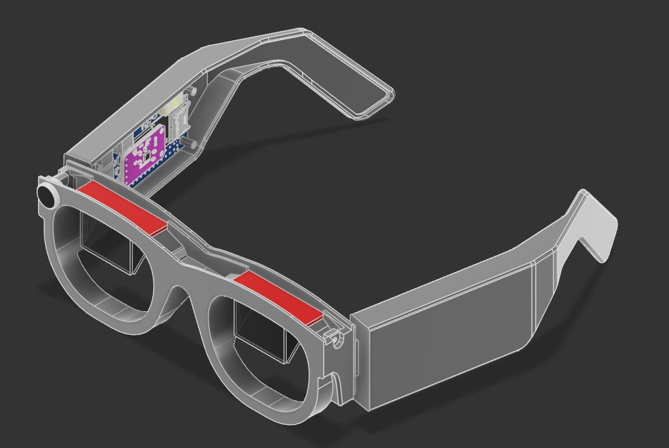
Source: Author (2025)
The TLens IoT was developed using the following components:
- Orange Pi Zero 2W: responsible for central processing and integration between modules.
- OLED I2C display module: responsible for displaying the transcribed text.
- Semi-reflective beam-diffusing lenses: project the display image directly onto the glasses’ lens.
- Lithium-ion batteries: provide the necessary power for the IoT device.
- Charge controller module: manages safe battery charging.
- Step-Up voltage regulator module: converts and stabilizes the voltage required by the hardware components.
- USB sound card: interfaces the microphone with the system, allowing for audio capture and digitization.
- AGC amplifier microphone module: captures ambient sound and increases audio gain.
In addition, the glasses feature their own operating system and a local artificial intelligence model responsible for speech processing. Moreover, the device includes a mobile application that allows the user to pair with the glasses, offering extra functions such as transcription history, font customization, notifications, and battery level monitoring. The software was developed using the React Native framework (with Expo support), JavaScript, Node.js, and CSS.
- Results and Discussions
This section presents the results obtained from the development and testing of the TLens system, as well as discussions about its performance, usability, and applicability.
  - Speech Recognition and Transcription
Speech recognition and transcription are the main pillars of the project, contributing to communication between deaf and hearing individuals. This process occurs in several stages, beginning with the capture of ambient audio through the microphone. Next, the audio is analyzed and processed by an artificial intelligence–based speech recognition model responsible for transcribing speech into text. This transcription is then sent to the OLED display, where, through a lens refraction scheme, it becomes visible to the hearing-impaired user.
Finding an artificial intelligence model capable of performing speech transcription locally, with good accuracy and acceptable delay, was a challenge. Several tests were carried out using different transcription models; however, most did not support local execution or showed low accuracy rates. After this testing stage, the Picovoice model was selected for its high processing speed, transcription precision, and ability to operate locally without the need for a constant internet connection.

Figure 2 - Process of performing transcription speed tests
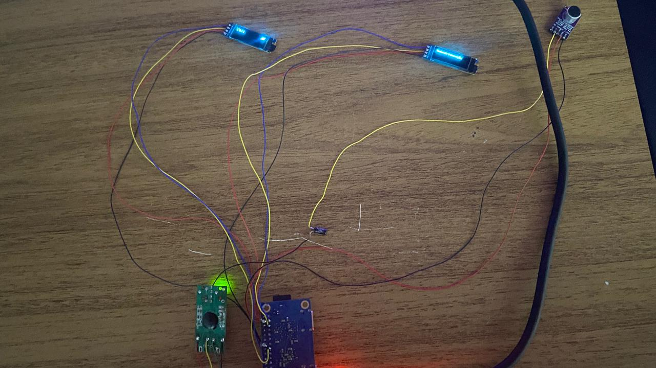
Source: Author (2025)
After implementing Picovoice, the tests showed that the average response time for transcription ranged between 0.5 and 1 second. The average transcription accuracy rate was approximately 90%. It was also observed that system performance was superior in environments with low noise levels—that is, where there was less sound interference during audio capture. This result reinforces the importance of functional assistive technologies, as pointed out by Souza and Mello (2021), who emphasize that a device capable of displaying captions can reduce reliance on interpreters and promote greater autonomy for people with hearing impairments.
  - IoT Development and 3D Printing of the Prototype
The prototype modeling stage was essential to validate the design, comfort, feasibility, and arrangement of the hardware modules. This stage aimed to integrate the physical components and provide a lightweight and comfortable structure, considering factors such as weight, size, and ergonomic fit to the user's face. The design was created using the Fusion 360 software, which contributed to developing different tests of size and usability until defining the final adopted model.
Eight distinct parts were modeled to interlock with each other. The structure includes specific compartments to house the processing board, batteries, display module, Step-Up voltage regulator module, charge controller module, USB sound card, and microphone, in addition to the main frame and semi-reflective lenses responsible for optical projection.

Figure 3 - 3D Printing
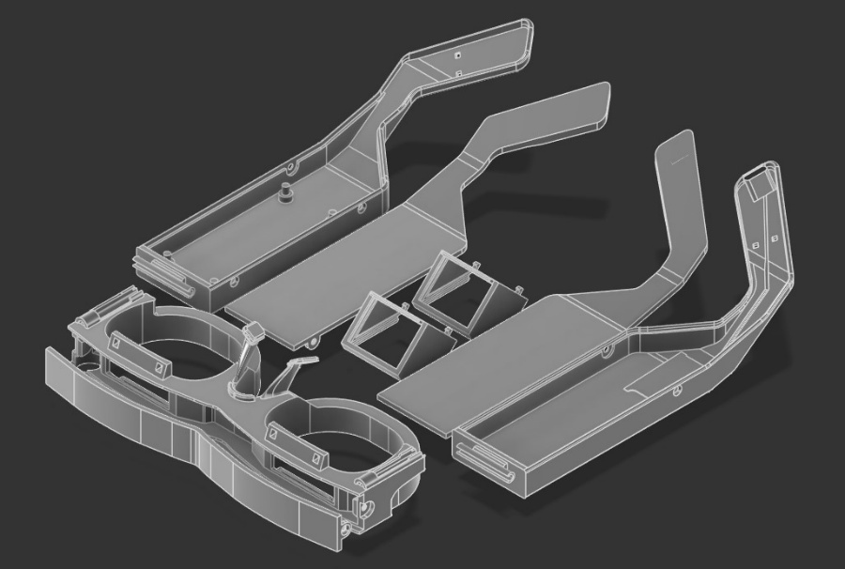
Source: Author (2025)
The 3D printing was performed using PETG material, as it provides strength, flexibility, and ease of printing — characteristics that ensure a good balance between durability and comfort. This material also offers excellent thermal and chemical resistance, contributing to the prototype’s longevity and safety during use.
After printing, the parts were assembled, sanded, and adjusted to fit the electronic modules, such as the Orange Pi Zero 2W board, USB sound card, AGC microphone module, Step-Up voltage regulator, charge controller module, battery, and OLED display. Furthermore, it is worth mentioning that the semi-reflective beam-diffusing lenses were cut using high-pressure water jets, ensuring a clean and precise finish before being fitted into the lens housing.
Figure 4 - TLens prototype assembled
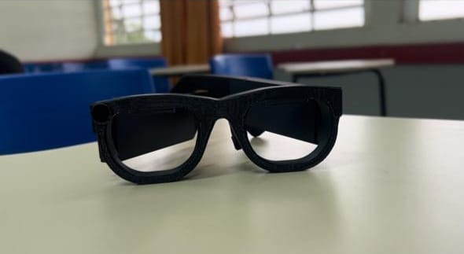
Source: Author (2025)
It was concluded that the final prototype presented good ergonomics, reduced weight, and appropriate component accommodation. The 3D printing process enabled rapid prototyping of different versions, allowing tests and selection of the best printing material. This phase was essential to validate the physical design of the TLens system and ensure its practical feasibility, aligning with Santos (2019), who discusses how the integration of IoT devices can positively impact people’s lives — in this case, specifically improving the lives of individuals with hearing impairments.
  - User Interface and Mobile Application
The user interface (UI) and the mobile application were developed with the goal of being intuitive, accessible, and easy to navigate. The application functions as an extension of the IoT device, including additional features such as transcription history, font customization, notifications, and real-time battery level monitoring of the device.
Below are some of the main screens of the TLens application:
Figure 5 - Welcome, Main, and History Screens of the TLens App
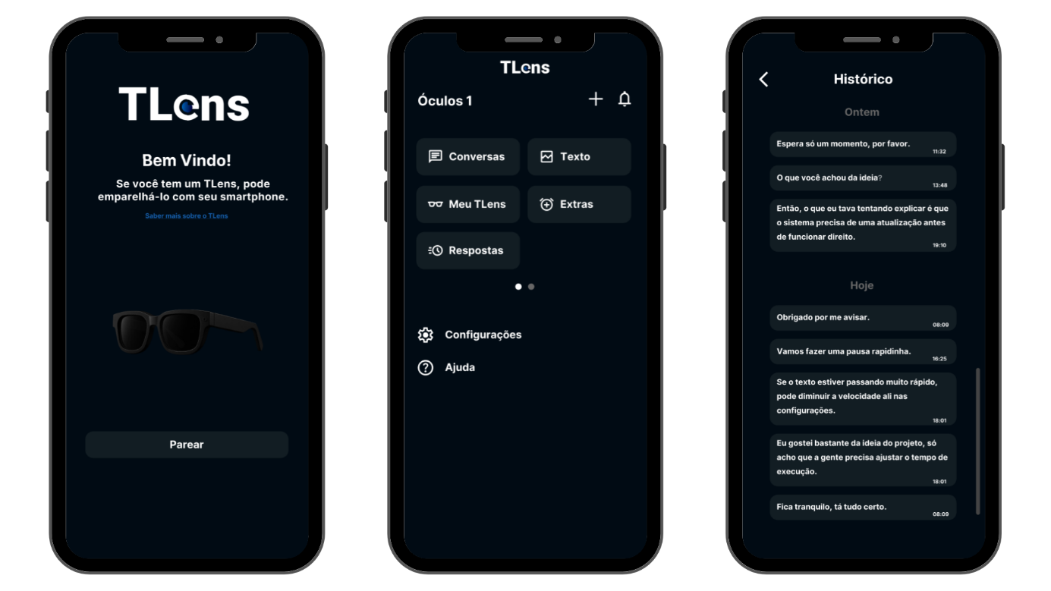
Source: Author (2025)
The screens shown above correspond to the following sections of the app:
- Welcome Screen: displays the initial message and allows pairing with the TLens device.
- Main Screen: provides access to control options, configuration menus, and the transcription history, as well as other additional functions.
- History Screen: lists previously performed transcriptions, allowing users to review past data.

Figure 6 - “My TLens”, Font Adjustment, and Advanced Settings Screens of the TLens App
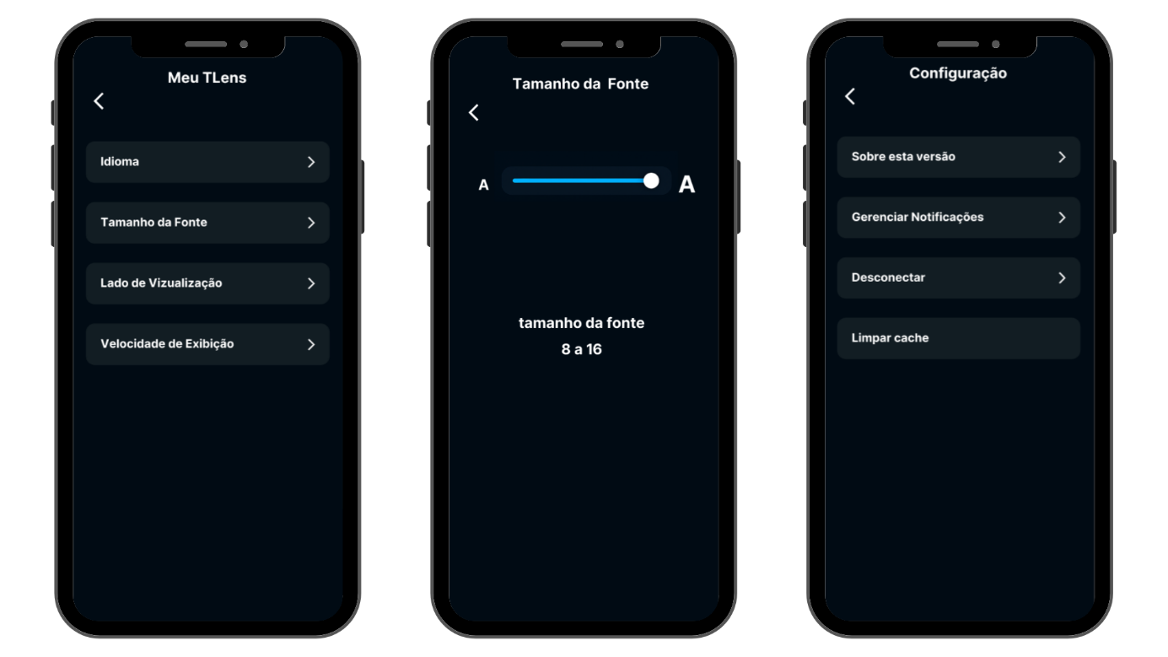
Source: Author (2025)
The screens presented above correspond to the following sections of the app:
- “My TLens” Screen: offers options such as transcription language, font size, display side, and subtitle display speed.
- Font Adjustment Screen: enables users to change the text size displayed in the subtitles of the glasses. This is part of the “My TLens” configuration menu, which also includes other personalization and device management options.
- Advanced Settings Screen: includes functions for cache cleaning, notification management, device disconnection, and app information.
- Conclusion
The TLens project, in its current stage, aims to reduce relational and communication barriers by using technologies such as the Orange Pi Zero 2W board, OLED module, semi-reflective lenses, and AGC-amplified microphone. Although it is functional and ready for use, future improvements will be made to the system to enhance the performance of the transcription process.
TLens stands out for promoting accessibility and social inclusion, making it possible for people with hearing impairments to interact more autonomously and naturally. During testing, the system showed satisfactory performance in displaying transcribed captions, demonstrating its feasibility as an assistive communication tool.
As a result, the project gave rise to TLens, a pair of glasses capable of transcribing ambient audio and displaying the text directly on the device’s lenses.
As future prospects, the goal is to improve speech recognition, reduce response time, and include multilingual support. Thus, the project reaffirms the potential of IoT technologies in creating accessible solutions aimed at inclusion.

References
BRASIL. Instituto Brasileiro de Geografia e Estatística. Pesquisa Nacional de Saúde: 2019: percepção do estado de saúde, estilos de vida, doenças crônicas e saúde bucal [National Health Survey: 2019: Perception of Health Status, Lifestyles, Chronic Diseases and Oral Health]. Rio de Janeiro: IBGE, 2021. Disponível em: https://www.ibge.gov.br. Acesso em: 18 maio 2025.
BRASIL. Lei nº 10.436, de 24 de abril de 2002. Dispõe sobre a Língua Brasileira de Sinais - Libras [Law No. 10.436, of April 24, 2002. Provides for the Brazilian Sign Language - Libras]. Diário Oficial da União: seção 1, Brasília, DF, 25 abr. 2002. Disponível em: http://www.planalto.gov.br/ccivil_03/leis/2002/L10436.htm. Acesso em: 18 maio 2025.
BRASIL. Lei nº 8.213, de 24 de julho de 1991. Dispõe sobre os Planos de Benefícios da Previdência Social [Law No. 8.213, of July 24, 1991. Provides for the Social Security Benefit Plans]. Diário Oficial da União: seção 1, Brasília, DF, 25 jul. 1991. Disponível em: http://www.planalto.gov.br/ccivil_03/leis/l8213cons.htm. Acesso em: 18 maio 2025.
CASELI, H.M.; NUNES, M.G.V. (org.). Processamento de Linguagem Natural: Conceitos, Técnicas e Aplicações em português [Natural Language Processing: Concepts, Techniques and Applications in Portuguese]. 3. ed. BPLN, 2024. Disponível em: https://brasileiraspln.com/livro-pln/3a-edicao.
EDUCAÇÃO PÚBLICA. As iniciativas de inclusão e de desenvolvimento de tecnologias assistivas em instituição federal de ensino no estado do Rio de Janeiro [Inclusion and Assistive Technology Development Initiatives in a Federal Educational Institution in the State of Rio de Janeiro]. Rio de Janeiro: Fundação Cecierj, 2023. Disponível em: https://educacaopublica.cecierj.edu.br/artigos/23/17/as-iniciativas-de-inclusao-e-de-desenvolvimento-de-tecnologias-assistivas-em-instituicao-federal-de-ensino-no-estado-do-rio-de-janeiro. Acesso em: 26 out. 2025.
MARCONI, Marina de Andrade; LAKATOS, Eva Maria. Fundamentos de metodologia científica [Fundamentals of Scientific Methodology]. 8. ed. São Paulo: Atlas, 2017.
OLIVEIRA, Thais S. de; et al. A inclusão de deficientes auditivos no sistema público de saúde [The Inclusion of Hearing-Impaired Individuals in the Public Health System]. Revista Foco, v. 11, n. 1, p. 57–66, 2024. Disponível em: https://ojs.focopublicacoes.com.br/foco/article/view/6791. Acesso em: 18 maio 2025.
SANTOS, Renata Ferreira dos; et al. Tecnologia assistiva e suas relações com a qualidade de vida de pessoas com deficiência [Assistive Technology and Its Relationship with the Quality of Life of People with Disabilities]. Revista de Terapia Ocupacional da Universidade de São Paulo, v. 28, n. jan./abr., p. 54–62, 2017. Disponível em: https://doi.org/10.11606/issn.2238-6149.v28i1p54-62. Acesso em: 26 out. 2025.
SANTOS, Sandro. Introdução à IoT: Desvendando a Internet das Coisas [Introduction to IoT: Unveiling the Internet of Things]. 1. ed. Santa Catarina: Clube de Autores, 2019.
SILVA, Ávilla I. S. et al. Segurança em aplicações de Internet das Coisas: Bluetooth Low Energy, casos de uso e vulnerabilidades [Security in Internet of Things Applications: Bluetooth Low Energy, Use Cases and Vulnerabilities]. In: Livro de Minicursos SBRT, 2020.
SOCIEDADE BRASILEIRA DE FONOAUDIOLOGIA. Guia de orientação na avaliação audiológica [Guidance Manual for Audiological Evaluation]. São Paulo: SBFa, 2023. Disponível em: https://fonoaudiologia.org.br/wp-content/uploads/2023/11/Guia-de-Orientacao-na-Avaliacao-Audiologica-DIGITAL-COMPLETO-FINAL.pdf. Acesso em: 11 nov. 2025.
SOUZA, Andre Luis A. de; MELLO, Evelyn Bernadino. As barreiras na comunicação de surdos com ouvintes: uma reflexão sobre os papéis de cada indivíduo [Barriers in the Communication Between Deaf and Hearing People: A Reflection on the Roles of Each Individual]. Revelli, v. 13, 2021. ISSN 1984-6576. Disponível em: https://www.revista.ueg.br/index.php/revelli/article/view/10241. Acesso em: 29 abr. 2025.
STELLING, Esmeralda Peçanha et al. Pais ouvintes e filho surdo: dificuldades de comunicação e necessidade de orientação familiar [Hearing Parents and Deaf Child: Communication Difficulties and the Need for Family Guidance]. Revista Espaço, Rio de Janeiro, n. 42, p. 15–25, jul./dez. 2014.
TORI, Romero; HOUNSELL, Marcelo da Silva (org.). Introdução a Realidade Virtual e Aumentada [Introduction to Virtual and Augmented Reality]. 3. ed. Porto Alegre: Editora SBC, 2020. 496p.

“The author(s) of this work declare that, during the preparation of the manuscript, the ChatGPT Artificial Intelligence (AI) tool/service was used to assist with spelling, grammar, and sentence agreement corrections. After using this tool/service, the authors edited and reviewed the content as necessary and assume full responsibility for the content of the publication.”

